A Complete Guide to Claude Code: Hooks

A deep dive into Claude Code’s Hooks system, including the event system, merge and decision mechanisms, Hooks at different layers, and practical usage in real plugins



zhaozhiming
Following
19 min read
·
May 1, 2026
336
22

In the previous article, we talked about the relationship between Slash Command and Skill, and saw how Claude Code is pulling what used to be scattered task entry points into a more complete structured system. But as we hand more and more capabilities to Claude Code, asking it to read code, modify files, run commands, and even call external services, a deeper question starts to emerge: what exactly do we rely on to control the boundary of its behavior? CLAUDE.md can tell it how it should work, and Skill can make it follow a more stable workflow, but in the end these are still ways of guiding the model, not truly constraining the execution process. You can write do not modify prod.env in CLAUDE.md, but whether that rule is followed consistently still depends on the model's own judgment.
Hooks are another answer from Claude Code. A Hook is not another kind of prompt, nor another way to inject context. It is a programmable control mechanism that runs inside Claude Code’s execution flow. For example, when Claude Code is about to call a tool, write a file, or execute a command, Hooks can step in before the action actually happens and decide whether to allow it, block it, or ask for human confirmation. The judgment does not depend on whether the model understands and remembers the rule. It depends on the code logic you wrote in advance, so it provides a more stable way to control behavioral boundaries. This article starts with the basic structure of Hooks, then walks through their event system, merge and decision mechanisms, behavioral differences across different layers, and actual usage in real plugins.

The Story of Hooks
Let us start with a story. After reading it, you will have a much deeper understanding of the concept of a Hook.
Press enter or click to view image in full size

In the story, the rules wrapped around every action are Hooks.
Claude Code itself is a very capable Aqing. It can read files, write code, execute commands, and call tools. But how it does these things depends on what it remembers at each moment, and you cannot watch it every second. You may want it to automatically format every Python file after it writes one, ask for confirmation before running dangerous commands, or log every read of certain sensitive files. If these requirements only live in repeated prompt reminders, Claude will eventually forget them.
The Hook mechanism lets you register processing logic that must run during Claude Code’s execution. These Hooks are not something Claude decides whether to run. They are hooks that the system forcibly triggers.

Understanding Hook Structure from settings.json
The most direct way to understand Hooks is to look at how they appear in a configuration file. Claude Code Hook configuration is written in settings.json, and the structure roughly looks like this:
{
"hooks": {
"PreToolUse": [
{
"matcher": "Write",
"hooks": [
{
"type": "command",
"command": "echo 'a write happened'"
}
]
}
]
}
}
Many people feel confused when they first see this structure. It has several layers of nesting, and the word hooks appears repeatedly at different levels while referring to different things. Let us unpack it from the outside in.
- First layer: the hooks object is the entry point of the entire Claude Code Hook system. Each key inside it is an event name, such as PreToolUse, PostToolUse, or Notification. You can think of it as an event registry: wherever you want to intervene, you register that event here. For more events, see this page.
- Second layer: under each event name is an array. Each element in the array represents a set of matching rules. It contains a matcher field and a hooks array. matcher decides when this group of rules takes effect. In the example above, matcher: Write means this group is triggered only when the tool name is Write. If matcher is omitted, it matches all cases under that event. For more information about matcher, see this page.
- Third layer: the hooks array inside the second layer contains the actual Hooks. Each Hook specifies its type and concrete behavior. For example, type: command means it executes a shell command, and the command field is the command to run. Different types have different fields. For the specific fields of a Hook element, see this page.
Here is a more visual mapping:
hooks <- Entry point of the whole Hook system
└── [Event] <- Event name, for example PreToolUse, triggered before tool use
└── [Matcher] <- Matching rule, for example matcher: Write, only matches file writes
└── [Hook] <- The actual processing logic, such as running a command
It is important to understand these three layers because they determine how we read Hook configuration later. Only after separating events, matching rules, and actual execution logic can we avoid confusion when looking at concrete examples.

A Quick Overview of Hooks
Let us quickly summarize the official documentation so we can get a more complete picture of Claude Code Hooks. As of now, the official Hook system looks like this:
Press enter or click to view image in full size
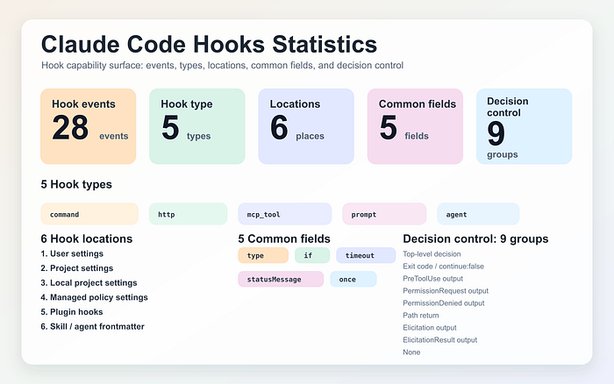
- The official documentation currently lists 28 events, covering key points such as sessions, tool calls, permissions, subagents, tasks, compaction, working directory changes, and file changes.
- There are 5 Hook types: command, http, mcp_tool, prompt, and agent. command is the most common form, but it is no longer the only form.
- Hooks can be defined in 6 kinds of locations: user settings, project settings, local project settings, managed policy settings, plugin hooks, and skill / agent frontmatter.
- All Hook types share 5 common fields: type, if, timeout, statusMessage, and once.
- Decision control can be divided into 9 categories. Different events can return different control results, so when looking at specific events later, you cannot rely on a single generic allow / deny model.

The Hook Event System
After understanding the structure of Hooks, we can look at the Hook event system. The official Claude Code documentation currently lists 28 events. These events cover all the key points in Claude Code’s execution process. Among many Agent tools, Claude Code has one of the most complete event systems, which is also the key reason it can support complex workflow control.

Events Are Siblings
When understanding Hook events, there is one common misunderstanding that should be clarified first: events do not have parent-child relationships, and there is no nested structure where one event contains another. Claude Code simply triggers the corresponding event based on its current position in the lifecycle, then runs the Hooks that match.
This point is worth emphasizing because some events can easily look subordinate from a semantic point of view. For example, PreToolUse and PermissionRequest: the former is triggered before a tool call, while the latter is triggered when the model requests user authorization. In many real scenarios, when Claude Code prepares to call a tool, it first triggers PreToolUse, and then immediately triggers PermissionRequest because this call requires user authorization. The two events happen almost back to back. This can make people feel that PermissionRequest is a subprocess of PreToolUse, or that the latter produces the former. In reality, they are two completely independent events, each with its own matching rules and independent execution, without interfering with each other.
Once you understand this, you will not try to use one event to cover or replace another when designing Hooks. Instead, you will treat them as independent intervention points along the execution path.
Since all events are siblings, where do their differences come from? In short, there are three:
- They are triggered at different positions: some are on the main flow, while others are on side paths
- They are triggered at different times: they have an order, but order does not mean nesting
- They have different capabilities: some can block the flow (Blocking), while others can only observe (Non-blocking)

Main-Flow Events and Side-Path Events
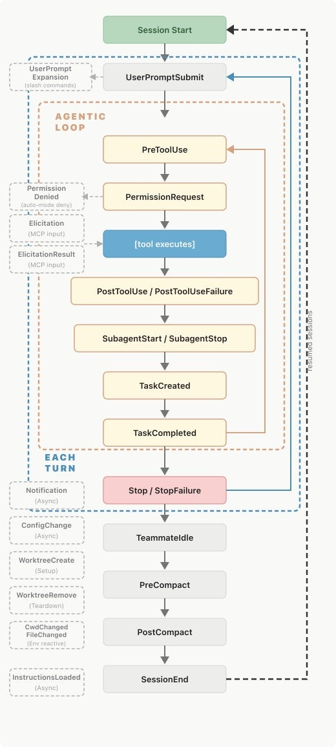
Image source: https://code.claude.com/docs/en/hooks#hook-lifecycle
The official Hook lifecycle diagram above divides events into two paths: one is the main flow that runs through the entire execution process, and the other corresponds to side-path events.
The main flow starts with SessionStart, then goes through key points such as PreToolUse, PermissionRequest, PostToolUse, and Stop. These events directly affect what Claude Code does next. As long as an event on this path supports blocking, it has a chance to stop the process before the action actually happens.
Side-path events are more like observation and notification channels, such as Notification and ConfigChange. They are not attached to the key control points of the main flow, so they usually do not change the main line of the current execution. They simply emit information at the right moment or perform extra work that does not affect the main flow.

Blocking and Non-blocking
Blocking means the result of the Hook directly affects Claude Code’s next behavior. Take PreToolUse as an example. When Claude Code is about to call a tool, it first executes all matching Hooks, waits for their results, and then decides whether this tool call should be allowed, blocked, or require user confirmation. Before the Hook results return, the main flow is paused.
Non-blocking is the opposite. Take Notification as an example. When Claude Code needs to notify the user, it triggers the Hooks registered on this event, but it does not stop the main flow because of the Hook result. You can use it to record logs, push messages, or synchronize state, but it will not intercept any key action already on the execution path.
For Blocking events, Hooks have two ways to block the flow, and their meanings are completely different.
The first is to let the script exit with exit 2. Claude Code interprets this as a system-level error, such as an unavailable tool, missing resources, or a broken environment. The model senses that the operation failed, so it may try to understand the error cause, or even try another way around it.
Note: exit 1 usually means failure in Unix conventions, but in Claude Code's Hook system, exit 1 is non-blocking. Claude Code ignores it and continues. Only exit 2 can truly block the flow.
The second is to let the script exit normally (exit 0), but print JSON to stdout containing a value such as "decision": "deny" (different events use different fields). Claude Code interprets this as a policy-level rejection. It is not a system error; it is a rule saying the operation is not allowed. The model senses that this is an explicit business rule, so it usually does not try to bypass it, but accepts the decision and adjusts its behavior. The JSON approach also supports attaching a rejection reason through fields like reason, and can even modify tool input parameters through fields like updatedInput. These are things exit 2 cannot do.

Hooks at Different Layers
After understanding these concepts, we now reach a very practical question: where exactly should Hooks be written?
In Claude Code, Hooks do not only live in a user’s own settings.json. With the introduction of Skill, Plugin, and Subagent mechanisms, Hook registration locations have become more diverse. They largely use the same configuration format and event system, but differ in scope, lifecycle, supported fields, and runtime transformation.

Hooks in Settings
The most basic Hooks are the ones written directly in settings.json. They can appear in user-level configuration ~/.claude/settings.json, project-level configuration .claude/settings.json, or local project configuration .claude/settings.local.json. In addition, organizations can define mandatory policies through Managed policy settings.
This kind of Hook takes effect from the start of Claude Code and lasts throughout the whole session. It is not cleaned up just because a task ends. The Hooks discussed in the previous sections all belong to this category. You can think of them as Claude Code’s resident Hooks. No matter what task is currently running, and no matter whether a Skill or Plugin is involved, these Hooks are always there.
The differences among these settings layers can be viewed simply as differences in scope:
Press enter or click to view image in full size
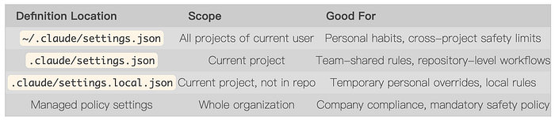
- User-level Hooks follow your machine and are suitable for rules you use repeatedly but do not want to duplicate in every project
- Project-level Hooks are part of the repository and are suitable for project rules the whole team should follow
- Local-level Hooks still apply to the current project, but the file itself is not committed to the repository, so it is better for machine-specific supplemental rules
- Managed policy settings are usually controlled by administrators and are used to define organization-level safety boundaries

Hooks in Plugins
Plugin is Claude Code’s extension mechanism. A Plugin usually contains its own CLAUDE.md, Skills, commands, and Hooks. Hooks in a Plugin are written in the Plugin's own configuration. When Claude Code loads the Plugin, it merges these Hooks with the main Hooks and executes them together. From a runtime perspective, Plugin Hooks and main Hooks participate equally. There is no question of one having a higher priority than the other.
But Plugin has one important limitation worth noting: Plugin Subagents do not support Hooks. The official Subagent documentation explicitly says that for security reasons, the hooks, mcpServers, and permissionMode fields in Plugin Subagent frontmatter are ignored.
The logic behind this limitation is not hard to understand. A Subagent is an execution unit with more restricted permissions. If a Plugin Subagent were allowed to register Hooks by itself, it would give a lower-privileged role the ability to modify execution-flow control rules, breaking the security boundary of the entire permission model.

Hooks in Skills
A Skill can define Hooks in its own frontmatter. Unlike resident Hooks in settings, Skill Hooks have a clearer lifecycle: they are registered when this Skill is invoked and automatically cleaned up after the Skill finishes. They do not remain as global Hooks.
Below is a frontmatter snippet from the planning-with-files Skill. It defines Hooks for three events:
---
name: planning-with-files
hooks:
PreToolUse:
- matcher: "Write|Edit|Bash|Read|Glob|Grep"
hooks:
- type: command
command: "cat task_plan.md 2>/dev/null | head -30 || true"
PostToolUse:
- matcher: "Write|Edit"
hooks:
- type: command
command: "echo '[planning-with-files] File updated. If this completes a phase, update task_plan.md status.'"
Stop:
- hooks:
- type: command
command: |
...
---
Every time this Skill calls tools such as Write, Edit, or Bash, it first prints the first 30 lines of task_plan.md so the model can always see the current task plan. After every file write or edit, it reminds the model to update the plan status. When the Skill ends, it runs a final check script.

Hooks in Subagents
A Subagent can define Hooks in its own frontmatter. The mechanism is similar to Skills: Hooks are temporarily registered when the Subagent starts executing, and automatically cleaned up after it finishes.
The official code-reviewer is a typical example:
---
name: code-reviewer
description: Review code changes with automatic linting
hooks:
PreToolUse:
- matcher: "Bash"
hooks:
- type: command
command: "./scripts/validate-command.sh $TOOL_INPUT"
PostToolUse:
- matcher: "Edit|Write"
hooks:
- type: command
command: "./scripts/run-linter.sh"
---
This Subagent works like this: before every Bash command, it calls a validation script to check whether the command is safe; after every file edit or write, it automatically runs a linter. When code-reviewer is invoked, these two Hooks are temporarily registered into the current execution environment. When it finishes, the Hooks are cleaned up and will not affect later tasks or other Subagents.
There is another detail worth noting. If you register a Stop event Hook in a Subagent's frontmatter, it is automatically converted to a SubagentStop event at runtime. This is because what ends is the Subagent's own execution, not the entire session, so its stop event semantically corresponds to SubagentStop, not the main flow's Stop.

Comparing the Four Hook Layers
So far, we have seen four different locations for Hooks. Their syntax is mostly the same, and the event system is basically the same. The real differences are scope and lifecycle:
Press enter or click to view image in full size
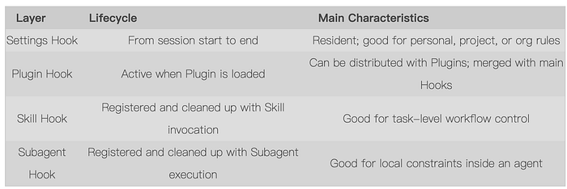
Main Hooks are resident. They are active from the start to the end of the session. Plugin Hooks become active when the Plugin is loaded. Skill Hooks and Subagent Hooks are temporary, registered and cleaned up according to their own execution cycles, and they do not pollute the global environment.
This means that the Hooks actually active at any moment in Claude Code may come from multiple layers. When a tool call happens, it may simultaneously match Hooks from the main configuration, the currently active Plugin, and the Skill currently being executed. That leads to the next question: when Hooks from different layers take effect at the same time, how does Claude Code handle their relationship?

Hook Merge and Decision Mechanisms
Let us answer that question in detail: when multiple Hooks take effect at the same time, how does Claude Code handle their relationship?
Press enter or click to view image in full size
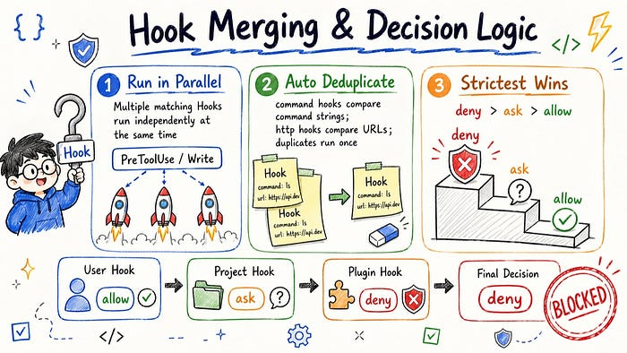

Parallel Execution
The most common case is that multiple Hooks are registered on the same event, and their matching conditions are identical or overlapping, but they define different processing logic. For example, you may register a PreToolUse Hook at the user level to log all file-write operations. At the same time, the project-level configuration may also register a PreToolUse Hook to check whether the write target is in a protected directory. Both Hooks match the same Write operation, but they do completely different things.
In this case, Claude Code executes both Hooks, and executes them in parallel. It does not skip one Hook just because another came from a higher layer, and it does not run them serially according to registration order. All matched Hooks start at the same time and complete their own logic independently.

Automatic Deduplication
Another case is that configurations from different layers happen to register exactly the same Hook: the same event, the same matching condition, and the exact same processing logic. This is not rare when multiple configuration layers coexist. For example, a Plugin and the project-level configuration may happen to define the same rule.
In this case, Claude Code automatically deduplicates them. The same Hook only runs once. The official documentation clearly explains the deduplication criteria: for command Hooks, it checks whether the command string is exactly the same; for http Hooks, it checks whether the URL is exactly the same. As long as these identifiers match, Claude Code treats them as the same Hook and keeps only one copy after merging.
This deduplication logic is important in practice. It means you do not need to worry that accidentally registering the same Hook at multiple layers will cause a script to run repeatedly. Claude Code handles that redundancy underneath. But the reverse is also true: if you really want the same script to be triggered separately under different conditions, you need to make sure their command strings or URLs differ, otherwise they may be mistakenly treated as duplicates and merged away.

Strictest Result Wins
The first two cases answer the question of what should execute. But when multiple Hooks have all executed and return different decisions, which one does Claude Code listen to?
The merge rule here is very clear: deny > ask > allow. As long as one Hook returns deny, the final result is deny. If there is no deny but there is an ask, the final result is ask. Only when all Hooks return allow is the final result allow.
So the rule has nothing to do with priority or which layer a Hook comes from. Claude Code does not care where each decision came from. It only cares about the strictest result among all decisions.
To illustrate with a concrete scenario, suppose you are about to perform a Write operation targeting ./prod.env, and three Hooks from different layers are matched:
- A user-level Hook says ordinary file writes are allowed and returns allow.
- A project-level Hook says writing .env files requires human confirmation and returns ask.
- The currently active Plugin also has a Hook saying modifications to prod.env are forbidden and returns deny.
All three Hooks participate in the decision and independently return their results. After Claude Code receives these three results, it does not compare which layer they came from. It directly decides based on the decision values. Since one result is deny, the final result is deny, and this write operation is blocked.
User-level Hook -> allow
Project-level Hook -> ask
Plugin Hook -> deny
-------------------------
Final decision -> deny (one deny is enough to block)
This design exists because security control should converge toward the strictest result. In an environment where multiple configuration layers coexist, if any layer believes an operation should not happen, that is enough to stop it. It does not need approval from other layers. This is consistent with the design of many security systems: allowing requires everyone to agree; rejecting only needs one veto.
Once you understand this, you will be clearer about what each layer should be responsible for when designing Hooks. User-level configuration is suitable for loose default policies, project-level configuration is suitable for concrete constraints specific to the current repository, and Hooks in Plugins and Skills are suitable for more focused security rules. Even if their criteria differ, Claude Code ultimately executes according to the strictest result. You do not need to repeat every restriction at every layer.

Real Cases
Next, let us look at two real cases and see what Hooks look like in actual projects.
We will look at two examples. One is the well-known superpowers Skill. Its core idea is to stop AI from jumping straight into coding, and instead make it work through an engineering process to ensure code quality and maintainability. The other is claude-code-warp. Warp is a terminal tool I like, but previously, when using Claude Code inside Warp, it could not sense Claude Code's running state. As a result, users did not know when Claude Code had finished a task or was waiting for permission confirmation, and had to keep switching back to the Warp terminal to check. So the Warp team developed the claude-code-warp plugin, using Hooks to notify users of Claude Code's runtime state through the Warp terminal. The two components have completely different goals, but both illustrate how Hooks are used in real projects.

Superpowers: Injecting Context with Hooks
superpowers is a plugin built around software development methodology. It provides a complete Skill system covering requirement clarification, planning, test-driven development, and code review. But if you open its hooks/hooks.json, you will find that it registers surprisingly few Hooks: only one.
{
"hooks": {
"SessionStart": [
{
"matcher": "startup|clear|compact",
"hooks": [
{
"type": "command",
"command": "\"${CLAUDE_PLUGIN_ROOT}/hooks/run-hook.cmd\" session-start"
}
]
}
]
}
}
The whole plugin attaches a Hook only to the SessionStart event. When triggered, it runs a session-start script. What this script does is inject the Superpowers skill instructions (the contents of the using-superpowers SKILL.md) into the session as additionalContext. More specifically, it detects the current platform and outputs JSON in the corresponding format. In the Claude Code environment, it outputs structured hookSpecificOutput, and Claude Code reads those capability instructions as context for subsequent work.
The core capability of Superpowers does not rely on Hooks for workflow control. Its Skill system is already complete enough. Here, the Hook only carries a very lightweight responsibility: ensuring that every session starts with the correct initial context available to the model. This is also an often underestimated use of Hooks. They do not always have to block or approve operations. Sometimes, bringing the right information in at the right moment is already valuable enough.

Warp: Turning Claude Code’s Lifecycle into a Terminal Experience
claude-code-warp takes a completely different approach. It does not inject context into Claude Code. Instead, it lets the Warp terminal know what state Claude Code is currently in: working, waiting for user input, requesting permission, or finished.
It registers noticeably more Hooks:
SessionStart -> on-session-start.sh
Stop -> on-stop.sh
Notification -> on-notification.sh
PermissionRequest -> on-permission-request.sh
UserPromptSubmit -> on-prompt-submit.sh
PostToolUse -> on-post-tool-use.sh
This set of Hooks covers several key state changes in a Claude Code session.
- SessionStart: sends plugin version and initialization information when the session begins
- UserPromptSubmit: notifies Warp that Claude Code has started working after the user submits a prompt
- PostToolUse: notifies Warp that the current blocking state has been cleared after a tool call ends
- Notification: triggers a notification when Claude Code is idle and waiting for user input
- PermissionRequest: sends the tool name and input preview to Warp when Claude Code requests tool permission
- Stop: reads session information when the task ends, extracts the user prompt and a summary of Claude's response, then sends a completion notification
These Hooks translate Claude Code’s internal lifecycle events into state events that Warp can understand. The plugin’s documentation also explicitly states that its Hook scripts construct a structured JSON object and hand it to Warp for parsing, so Warp can drive the notification center, system notifications, and related experiences.
For example, the script corresponding to PermissionRequest takes the tool name and parameter input from the Hook input, then generates a readable summary. This way, when Claude Code wants to execute a tool and needs your confirmation, Warp does not merely know that there is a permission request; it can also show roughly what Claude Code wants to do.
The Stop script is even more typical. It does not simply say the task is done. Instead, it reads the current session content, extracts the last user input and Claude's response from that session, and truncates them to a length suitable for notification display. With that, one Hook turns Claude Code's internal records into a completion notification the user can perceive.
This example introduces another common use of Hooks: they can act as an event bridge, synchronizing Claude Code’s execution process to external systems.

Learn from Real Hooks
Through the Superpowers and Warp examples, we can see that Hook syntax itself is not complicated. What is truly worth learning is why they choose particular events, and what behavior they design for each intervention.
It is hard to build intuition about Hooks by reading syntax and documentation alone. A more effective method is to look at Hook configurations in real plugins: why they choose a certain event, why they use a certain matching rule, and why they put certain logic in a Hook instead of a Skill or Slash Command. After seeing enough examples, you gradually build judgment about which problems are suitable for Hooks, and which should actually be handled by CLAUDE.md or Skill.

Summary
This article started from the question of how Claude Code controls the behavioral boundaries of AI, then walked through Hook configuration structure, the event system, registration methods at different layers, merge and decision mechanisms, and real plugin usage.
Unlike CLAUDE.md, Slash Command, and Skill introduced in the previous two articles, Hooks do not guide how the model should understand a task. Instead, they provide a programmable intervention layer while the model is executing the task. Their judgment does not depend on the model's understanding, but on the code logic you wrote in advance, so they provide deterministic guarantees. This is also their irreplaceable position in the Claude Code system: CLAUDE.md helps the model understand the project, Skill organizes complex tasks, and Hook guards the boundary at key points.
But precisely because Hooks run real code, their effects are immediate and irreversible. A script with the wrong exit code may unexpectedly interrupt the flow. A Stop Hook with poorly handled exit logic may trap the session in a loop. So when designing Hooks, beyond deciding when they should intervene and what decisions they should make, you should also handle boundary cases and error paths as seriously as you would in any production code.

References
- Automate workflows with hooks
- Hooks reference
- claude-code-hooks-mastery
- Claude Code Hooks: A Practical Guide to Workflow Automation
- Hooks & Lifecycle Automation

